Experiment 4
Student Name: Pulkit UID: 23BCS11733
Branch: CSE Section/Group: KRG 2-B
Semester: 6th Date of Performance: 03/02/2026
Subject Name: System Design Subject Code: 23CSH-314
- Aim: To design and analyze a scalable OTT (Over-The-Top) video streaming platform similar to Netflix / Amazon Prime, which allows users to register, subscribe, search, and stream video content efficiently while ensuring high availability, low latency, and massive scalability using modern distributed system concepts.
- Objective:
- To identify functional and non-functional requirements of an OTT streaming system
- To design a high-level architecture (HLD) for a large-scale video streaming platform
- To understand video streaming protocols (HLS / DASH) and adaptive bitrate streaming
- To apply CAP theorem trade-offs in OTT systems
- To understand the role of Kafka, CDN, object storage, chunking, and encoding pipelines • To study how availability is prioritized over consistency in media streaming systems
3. Tools:
- Draw.io – System Architecture & HLD Diagram
- MySQL – User, subscription, and payment data
- MongoDB / NoSQL DB – Video metadata storage
- ElasticSearch – Search functionality for movies and TV shows
- Apache Kafka – Asynchronous event streaming and video pipeline coordination
- Redis / CDN Cache – Caching frequently accessed content • Blob Storage (Amazon S3 equivalent) – Video and media storage
4. System Requirements:
A. Functional Requirements:-
- Client should be able to create an account on the OTT platform
- Client should be able to login and manage sessions securely
- Client should be able to subscribe to different plans after successful login
- Client should be able to search movies / TV shows using title or keywords (ElasticSearch)
- Client should be able to watch videos in multiple resolutions (480p, 720p, 1080p, 4K)
- System should support adaptive streaming based on internet bandwidth
- Client should be able to view thumbnails, descriptions, and metadata of videos
- (Optional) System may support recommendations based on viewing history
B. Non-Functional Requirements:-
1. Scalability
- Target Users: 200–300 Million active users
- Total Videos: ~20,000 videos, average duration ~1 hour
- System must handle millions of concurrent streams
2. Availability vs Consistency (CAP Theorem)
- Availability >>> Consistency Reason:
- Video streaming must not stop even during partial failures
- Slight delays in metadata updates are acceptable
- Subscription and payment data require stronger consistency Example:
- Video playback unavailable → Critical failure
- Slight delay in subscription update → Acceptable
3. Latency
- Target latency: 50–80 ms
- Video should play with zero or negligible buffering
5. High Level Design (HLD):
The system follows a microservices-based architecture:
API Gateway
- Handles authentication, authorization, routing, and rate limiting
User Service
- User registration, login, JWT-based authentication
- Stores user data in MySQL
Subscription & Payment Service
- Manages subscription plans and payments
- Ensures strong consistency for transactions
Search Service
- Uses ElasticSearch for fast movie/TV show search
Video Metadata Service
- Stores metadata (title, description, thumbnails) in NoSQL DB
Video Upload & Processing Pipeline
- Uploaded videos are stored in Blob Storage
- Chunker Service splits videos into small segments
- Video Encoder generates multiple resolutions (480p, 720p, 1080p, 4K)
- Kafka coordinates asynchronous processing
Streaming Service
- Generates HLS (.m3u8) or DASH (.mpd) manifests
- Client fetches chunks based on bandwidth
CDN
- Caches most frequently watched video chunks
- Reduces latency and server load
6. Video Streaming Workflow:
- User clicks Play Video
- Client requests manifest file (.m3u8 / .mpd)
- Manifest contains URLs of video chunks with different bitrates
- Client measures network bandwidth
- Appropriate resolution chunks are fetched dynamically
- CDN serves cached chunks if available
- Video playback continues smoothly with adaptive bitrate
7. Scalability Solution:
- Horizontal scaling of all microservices
- API Gateway acts as load balancer
- Kafka decouples video processing pipeline
- CDN caching minimizes latency and origin load
- Blob storage efficiently stores large video files
- Stateless services allow easy scaling
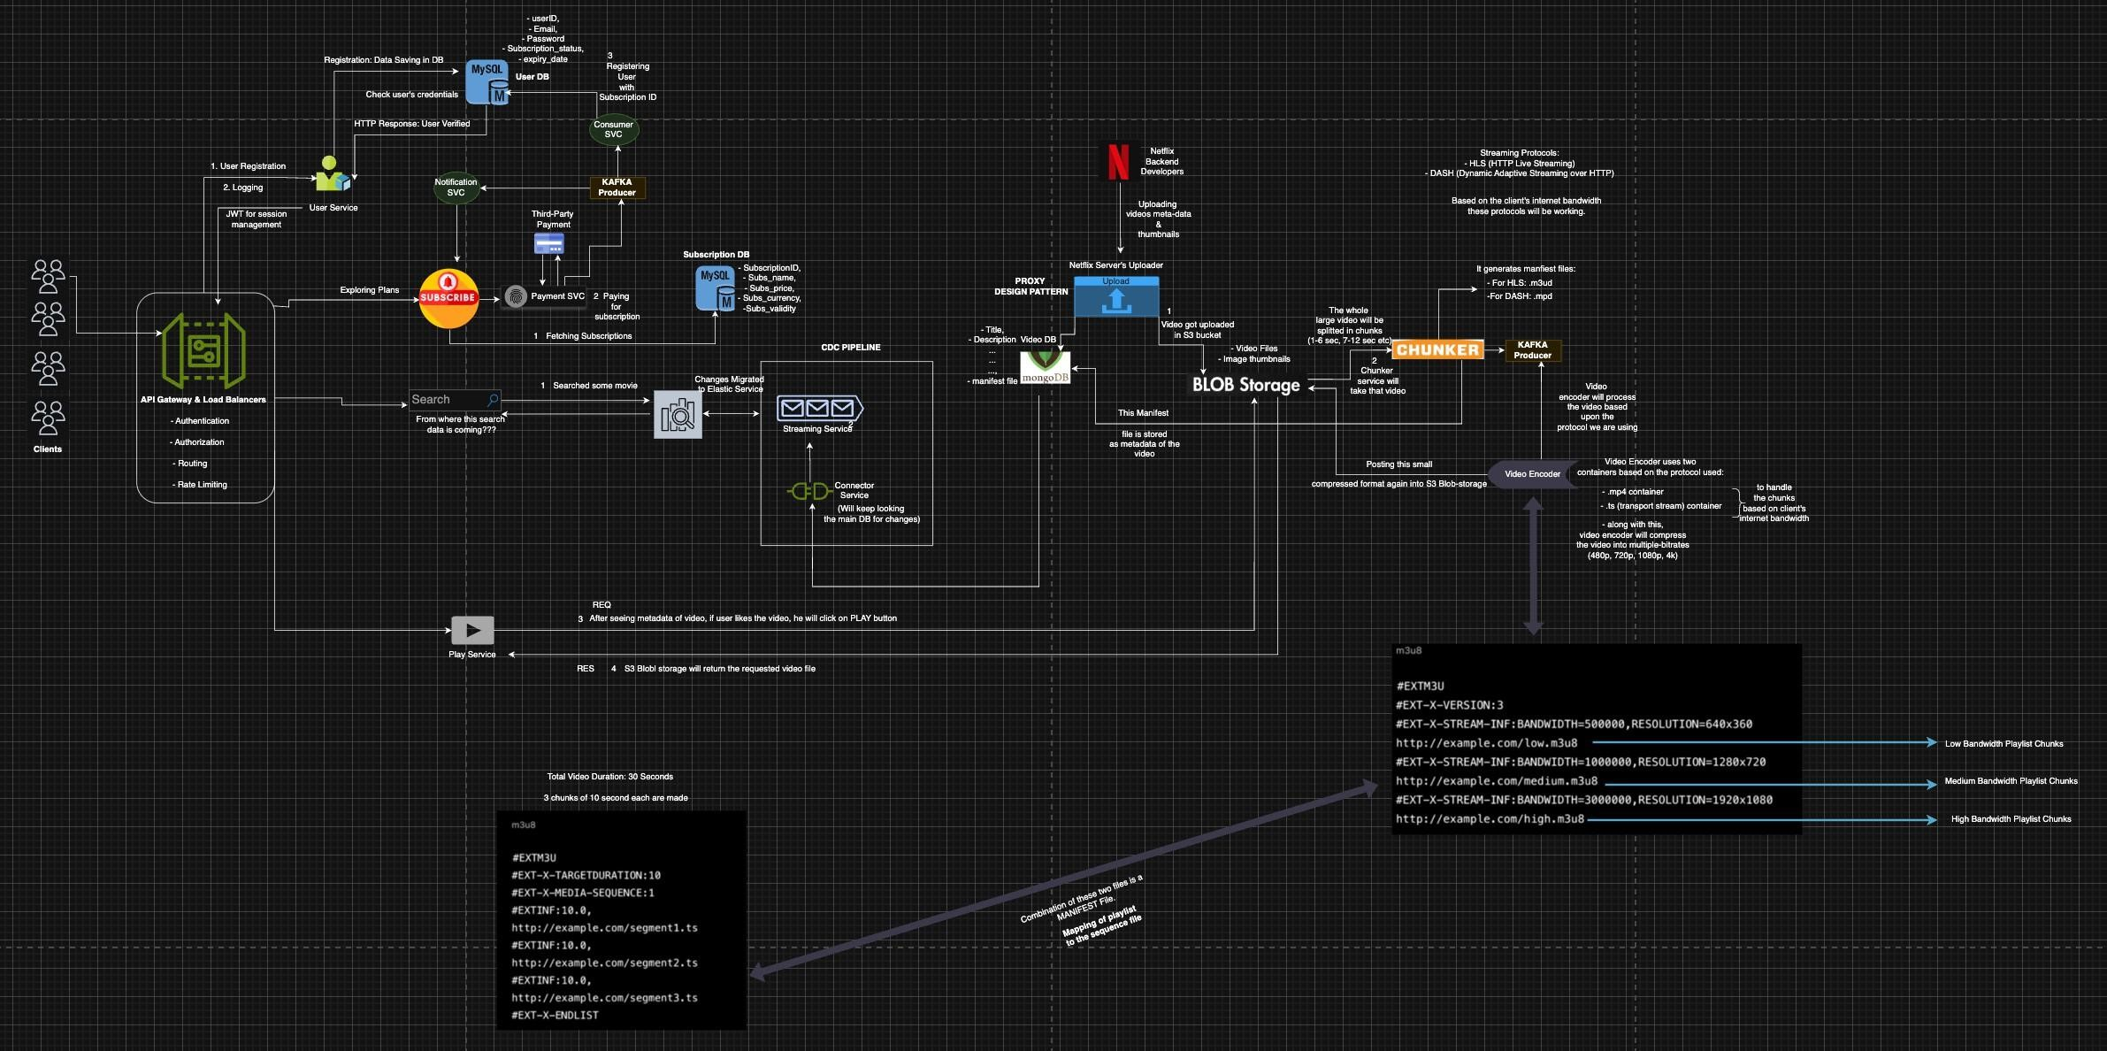

COMPUTERSCIENCE&ENGINEERING
7. Learning Outcomes (What I Have Learnt):
- Understood how real-world OTT platforms like Netflix are designed
- Learned difference between functional and non-functional requirements
- Gained strong understanding of adaptive bitrate streaming (HLS/DASH)
- Understood CAP theorem trade-offs in streaming systems
- Learned how Kafka, CDN, and chunking pipelines work together
- Learned how to design highly available, low-latency distributed systems

